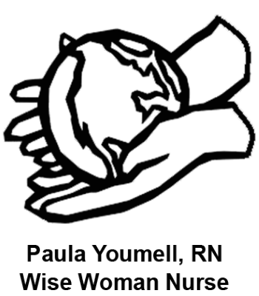
Paula Youmell, RN
Functional Medicine RN – Natural Health Educator – Herbalist

(315) 212-3066 www.PaulaYoumellRN.com

Consultation Pre-Appointment Information Form
You do not need to print this form. Please read thoroughly and understand my policies, etc.

- Please, before your appointment, read this all carefully
- Please sign the self-responsibility contract of consent on your health history form
In working with Paula Youmell, RN, (PY, RN) I am aware I am taking self-responsibility for my own health. I acknowledge that PY, RN is not a physician and that PY, RN is not diagnosing or prescribing. This is a health counseling relationship with no actual physical exam or taking of vital signs. Food, herbs, and/or supplements that are discussed as options for regaining optimal health should be discussed with my physician as to the compatibility with my physician’s recommended treatment plan. The support and advice I receive from PY, RN is in my hands to implement, or not. I take full responsibility for all of the results and consequences of my actions making these suggested changes in my life.
What I Am, What I Do, What I Am Not and Do Not Do:
I am a Registered Nurse and I prefer to practice from a natural health education perspective as healing comes through nature and, as humans, we are nature. I am trained in school health education, adult wellness-fitness promotion, holistic health coaching, herbal medicine, energy healing, yoga, whole food nutrition, and functional medicine for health coaches. Click here to read more about my traditional and natural health training. I work with you to discover the underlying causes of your health challenges and create a supportive plan for you to heal yourself. I do not diagnose or treat any disease or do physical exams. Your full self-responsibility information can be read here: http://www.paulayoumellrn.com/self-responsibility

Sign this part on the health history form:
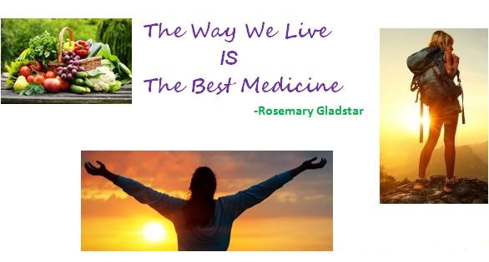
Name: Date:

Please Note Changes in Business Policies:
Consults are approximately 1 hour sessions (initial session can be a bit longer to get a grasp on things) to address your critical questions & health symptoms. We work on the most important symptoms first. As those symptoms are resolved, we address the next urgent symptoms with subsequent sessions. This is the process of Health Education Coaching.
Consult Includes: $75
- pre-appointment thorough review of your health history forms,
- 1 hour session together in person or via phone,
- follow up email with attached personalized - educational hand-outs, and
- 2 week basic email Q & A Support related to our current session together.
- Lab work review, beyond the most current appointment's information, needs to be brought to a subsequent session.

Getting to the root causes of your health issues is a commitment for life that you, we, take one step at a time. I work best with people who can take in what I have to offer for Natural Health Education information and proactively make it happen in their lives. This is true Lifestyle Medicine that is Self Healing. I look forward to walking your healing path with you. Cheers & Be Well, Paula

Important: Your Homework with this natural health education & self healing session:
When I send you your follow up email that includes our session information, educational handouts and links, and a flexible outline for you to move forward weaving your own self healing path, I suggest that you take the time to:
- Create an outline of what you think you are supposed to be doing
- Add the whys, the wellness priorities, and the actions you are going to take working towards healing your own health based upon your understanding of the information we talk about in our session together and the educational info I send in the follow up email.
- Ask questions about things you are unsure of.
- I will not hound you about this, it is part of your self healing accountability.
This action, on your part, helps to keep you organized & motivated.

"The desire to change a self-destructive or addictive habit has to mature into an intense will to transform before it galvanizes into action." Sally Kempton

“The role of the teacher is to provide the practice. The practice then becomes the teacher.”
David Crow
*Please Note: *Credit / debit cards are accepted for payment using PayPal payment processing with a 3.5% electronic processing fee added to session fee.

Session Cancellations: A minimum 24 hours courtesy advance notice is required to cancel or reschedule your appointment.
Short-notice cancellations, who want to schedule an appointment again, will be required to pay the 1st hourly fee, plus the online service charge, via PayPal to schedule another appointment. This payment will be made when you make the appointment to hold the session time slot. This assures me of your commitment to your health & healing process. PayPal payments to: pyoumell@gmail.com. Thanks.

Paula Youmell, RN, Wise Woman Nurse® is a registered trademark of
Hands On Health Holistic Healing (HOHHH).
Paula Youmell, RN, is the sole Natural Health-Functional Medicine Practitioner @ HOHHH.

